- \Operation\ Product hopper – monitoring, fill level\Monitoring, fill level
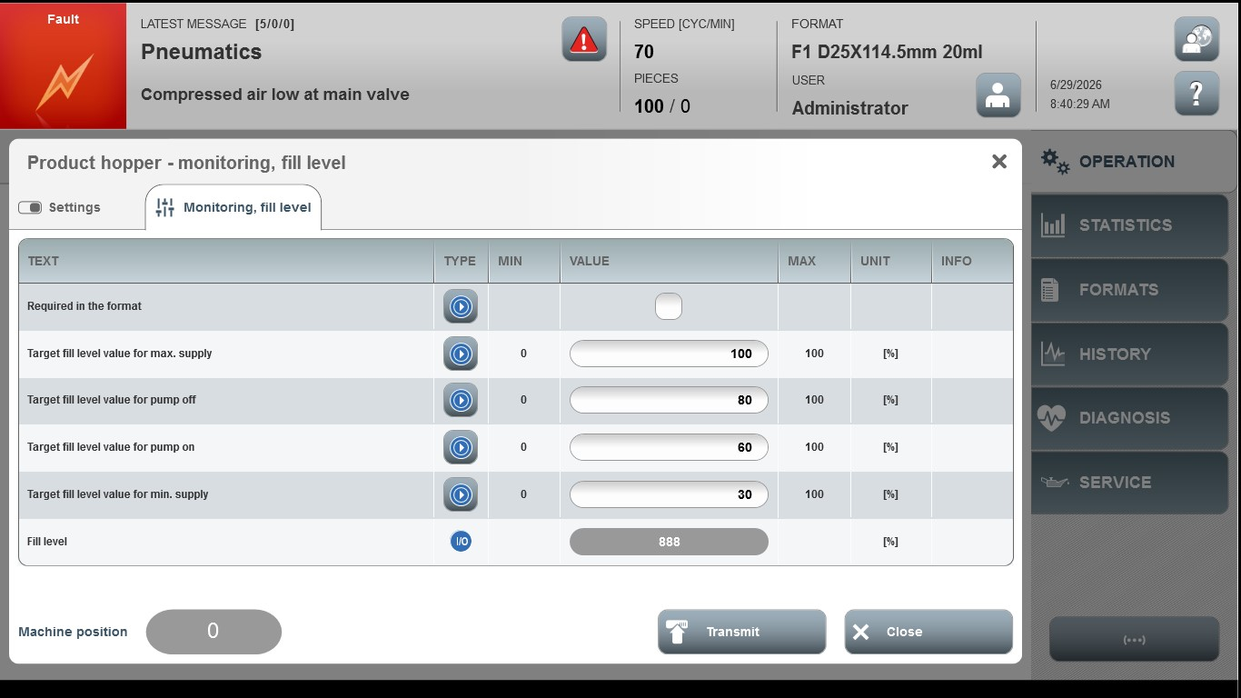
Acceptance criterion | Limits | Pass / Fail: Dev-No. | Date | Initials
Screen matches screenshot | N / A
Target fill level for max. supply | 0 … 100
Target fill level for product pump off | 0 … 100
Target fill level for product pump on | 0 … 100
Target fill level for min. supply | 0 … 100

